Letter from Laura Amelia (Jones) Geopfarth to sister Anna Irene (Jones) Hawk
on October 26, 1906 telling of their mother Margaret Cowan’s death.
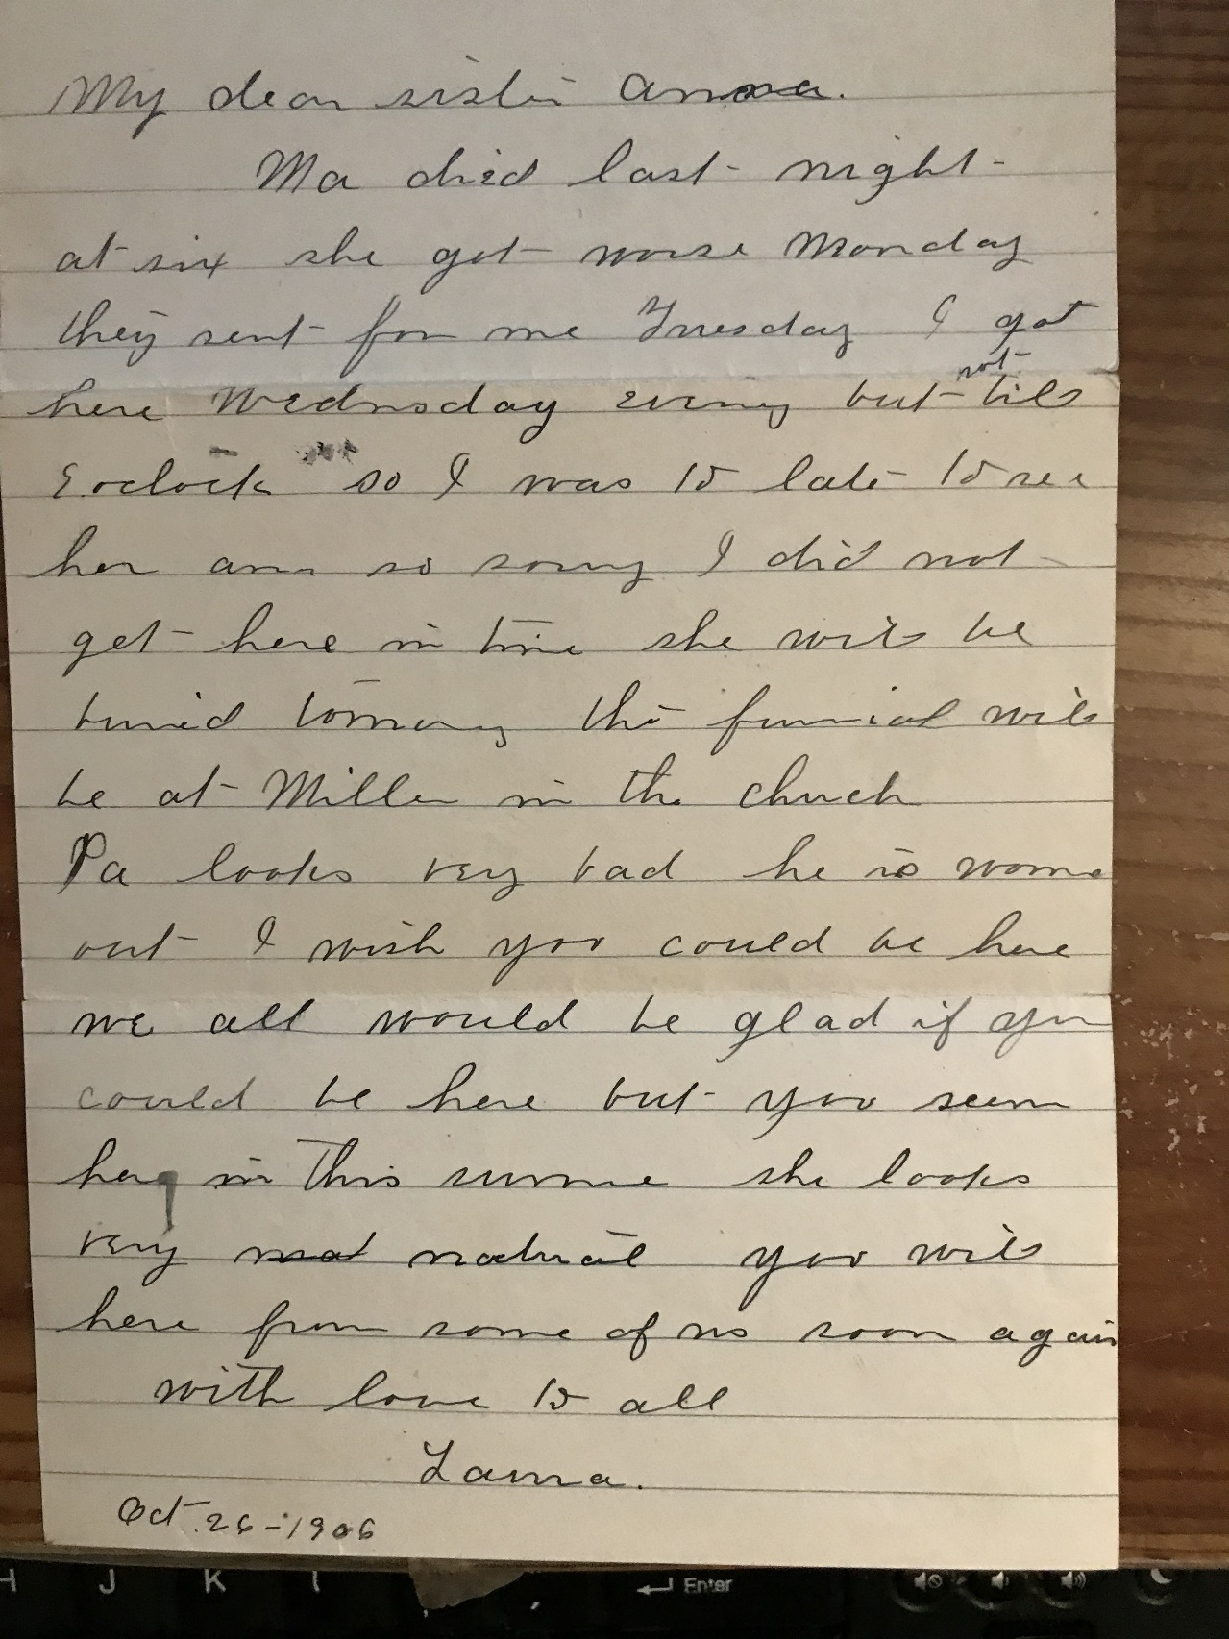

Translation:
"My dear sister Anna: Ma died last night at six. She got worse Monday. They sent for me Tuesday. I got here Wednesday evening but not till 6 o'clock so I was 15 (minutes) late. Am so sorry I did not get here in time. She will be buried tomorrow. The funeral will be at Miller (Nebraska) in the church. Pa looks very bad he is so worn out. I wish you could be here. We all would be glad if you could be here but you seen her this summer. You write here from some of us soon again with love from all, Laura 10-26-1906"

