Letter from Flora (Jones) Darbyshire to sister Anna Irene (Jones) Hawk
on November 8, 1906 telling of their mother Margaret Cowan’s death.
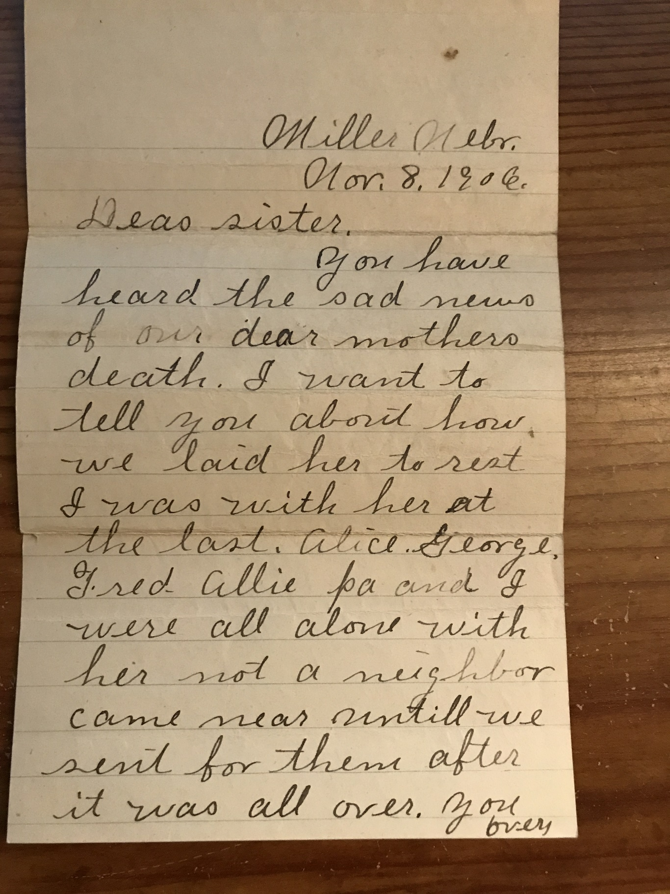
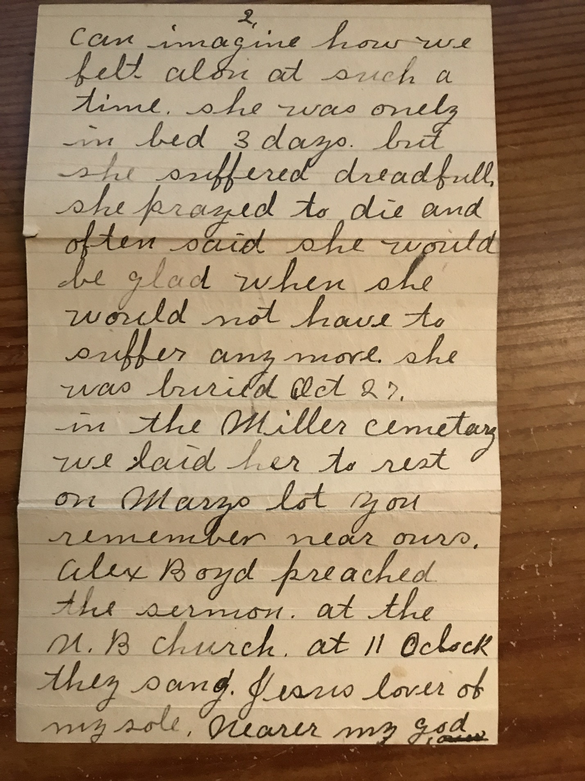
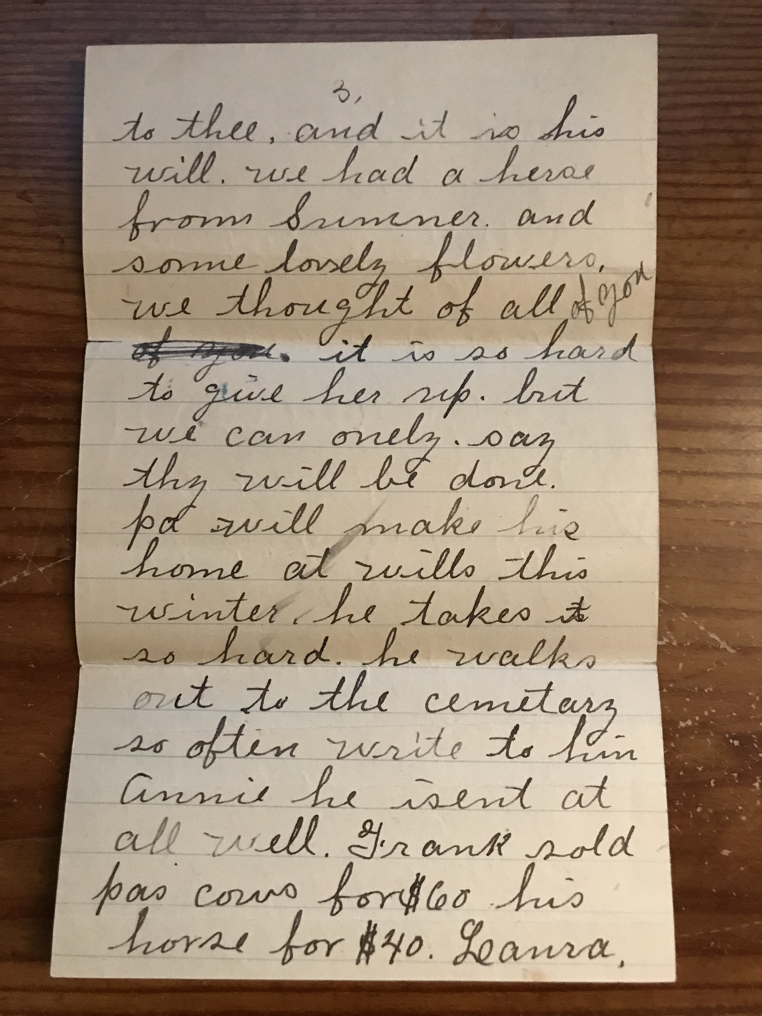
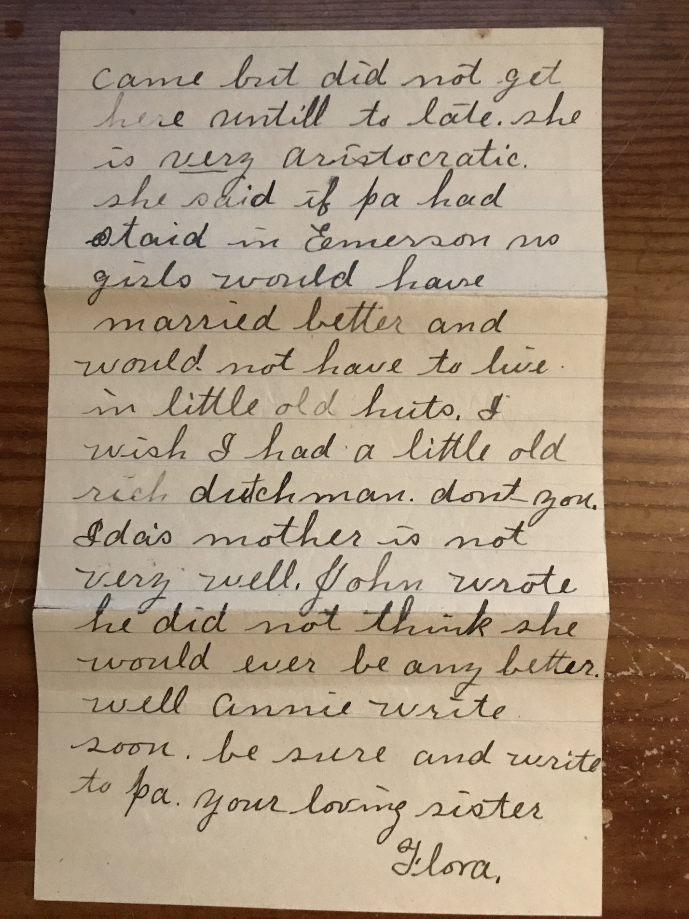
Translation:

Dear sister, You have heard the sad news of our dear mother's death. I want to tell you about how we laid her to rest. I was with her at the last. Alice, George, Fred, Allie, PA and I were all alone with her. Not a neighbor came near until we sent for them after it was all over. You can imagine how we felt alone at such a time. She was only in bed 3 days but she suffered dreadfull. She prayed to die and often said she would be glad when she would not have to suffer any more. She was buried October 27 in the Miller cemetary. We laid her to rest on Marzy's lot you remember near ours. Alex Boyd preached the sermon at the U.B. Church at 11:00. They sang "Jesus Lover of My Soul", "Nearer my God To Thee" and "It Is His Will." We had a hearse from Sumner and some lovely flowers. We thought of all of you. It is so hard to give her up but we can only say thy will be done. Pa will make his home at Wills this Winter. He takes it so hard. He walks out to the cemetary so often. Write to him Annie. He isn't at all well. Frank sold Pa's cows for $60, his horse for $40. Laura came but did not get here until too late. She is very aristocratic. She said if Pa had staid in Cemerson no girls would have married better and would not have to lie in little old huts. I wish I had a little old rich dutchman, don't you. Ida's mother is not very well. John wrote he did not think she would ever be any better. Well Annie write soon. Be sure and write to Pa. Your loving sister, Flora.

